**IMAT3451 FINAL YEAR PROJECT - ETHICAL REVIEW FORM**

The University requires all undergraduate final year projects to undergo an ethical review and, where human research ethical issues are identified, to ensure that these issues are addressed.

For the majority of Computing Final Year Projects, the outcome will be either ‘No ethical issues’ or ‘Minor/Major ethical issues which have been addressed’; in these cases approval can be given by the supervisor. In the unlikely event that the outcome is ‘Ethical issues that have not been addressed’, the completed form will need to be forwarded to the Faculty Research Ethics Committee.

**Student Name** **Programme**

Computer Science

Mohit Gautam P15194912

Momhtoh

**Project Title**

*Restaurant table reservation android app. (Table4Me)*

**Brief description of proposed activity and its objectives:**

The project will develop an android application, which would be mainly targeted for restaurants. The app will aid the restaurant allowing them to make their table booking system easier. it will also aid the app users which will allow them to choose the table of their choice, without having to call up the restaurant. I will create this application through android developer studio and I will have to find some sort of way to create customer database, which my supervisor will recommend it to me.

**Ethical Issues Identified: How these will be addressed:**

However there are some solution which can be used to address the issues. The survey will be completely anonymous, the purpose of the survey Is only to find out people opinions about my project, and whether if they think it will have any affect in business perspective way.

There will be very minor ethical issues which could be addressed. Some of the issues are like where, I have to deal with real life people whilst conducting a survey, which many people may feel like not giving out there personal information/data.

Another ethical issues that I have identified is using pictures of the restaurant which could lead to problem such as copyrights issues.

As my project will need images and table plans , I will use generic restaurant plan which I will make up myself. I will also not use any types of personal data exchange which could lead to my project having with ethical issues. And all of the users will be generic text users and there wont be any sort of personal data used.

**Checklist**

Has the project proposal identified any of the following research procedures?

1. Gathering information about human beings through: Interviewing, Surveying,

Questionnaires, Observation of human behaviour **Yes** / No

2. Using archived data in which individuals are identifiable Yes / **No**

3. Researching into illegal activities, activities at the margins of the law or

activities that have a risk of personal injury Yes / **No**

4. Supporting innovation that might impact on human behaviour

e.g. Behavioural Studies Yes / **No**

**If ‘Yes’ to any of 1-4 above: have you considered the following?**

 Providing participants with full details of the objectives of the research

 Providing information appropriate for those whose first language is not English

 Voluntary participation with informed consent

 Written description of involvement

□ Freedom to withdraw

□ Keeping appropriate records

□ Signed acknowledgement and understanding by participants

□ Consideration of relevant codes of conduct/guidelines

**Ethical Review Outcome**

□ 1. No ethical issues

** 2. Minor ethical issues which have been addressed and concerns resolved**

□ 3. Major ethical issues which have been addressed and concerns resolved

□ 4. Ethical issues that have not been resolved/addressed

**Authorisation**

*If the outcome is no. 3 or 4 above, this form should be forwarded to the Faculty Research Ethics Committee.*

Signature of student 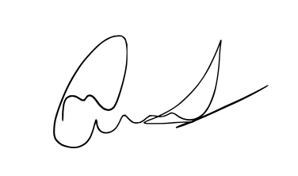 Date-27/10/17

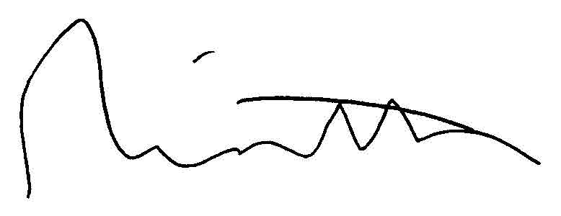

Signature of supervisor Date 27/10/17